TECHNICAL PROJECT REPORT

# Title of Invention / Project: Voice Control Pet

# Team Members / Inventors:

|  |  |  |  |  |  |
| --- | --- | --- | --- | --- | --- |
| **S. No.** | **Name** | **Department** | **Designation** | **Mobile** | **E-Mail** |
| 1. | Rallapalli Dinesh Sai | ECE | STUDENT | 9490851597 | rallapallidineshsai33@outlook.com |
| 2. | Sarthak | ECE | STUDENT | 9467485265 | sarthakchoudhary99@gmail.com |
| 3. | Arjun | ECE | STUDENT | 7006344472 | gupta.arjun94199@gmail.com |
| 4. |  |  |  |  |  |
| 5. | Khushal Thakur | ECE | Mentor | 9646030764 | khushal.thakur@cumail.in |
| 6. | Anshul Sharma | ECE | Mentor | 9478697475 | anshulsharma.ece@cumail.in |
| 7. | Kiran Jot Singh | ECE | Mentor | 9463909689 | kiranjotsingh.ece@cumal.in |
| 8. | Divneet Singh Kapoor | ECE | Mentor | 9878422653 | divneet.ece@cumail.in |

Section – 1 (IPR Related)

# Brief Abstract (500 words):

* **Problem faced and how solved it.**
* My project is to make to voice control pet. I made it with all my possibilities but I faced some problems during testing. I started troubleshooting the problems, then I recognised that my body structure of body facing some problems when it is turning left and right. I decided to verify the hardware part of the body, when I checked I didn’t find any problem, then I decided to check programme code. When I verified the code I found some loop holes and thought to modify the problems. Then I modified the code. Now it is working in a perfect manner.
* **Additional modifications that I can add to my model.**
* The additional specifications that I can add to my model are:

1. I can add a ultrasonic sensor for obstacle detection.
2. I can add a camera for capturing pictures.
3. My model can be modified from voice control to gesture control.
4. A LCD can be added to display pictures.

# Existing state-of-the-art and Drawbacks in existing state-of-the-art

|  |  |  |
| --- | --- | --- |
| **S. No.** | **Existing state of art** | **Drawbacks in existing state of art** |
| 1 | https://www.youtube.com/watch?v=fNFVHupdBic&t=1s | Its getting stressed to recognize the sound. |
| 2 |  |  |

# Novel/Additional modifications that you can propose to improve upon drawbacks

* The additional feature that I can add to my project is fixing a camera.
* The additional feature that I can add to my project is fixing a ultrasonic sensor.

# Advantages

* For capturing the images.
* To detect obstacles.

# Block Diagram

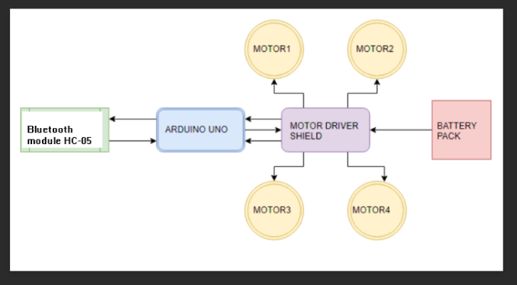

Section – 2 (Real Project)

# Materials

* Arduino UNO
* L298N Motor Driver
* Bluetooth Module HC-05
* 4 motors with wheels
* Three wood pieces for body
* Wires and Jumper wires
* 9 V cell
* 12 V cell

# Circuit Diagram

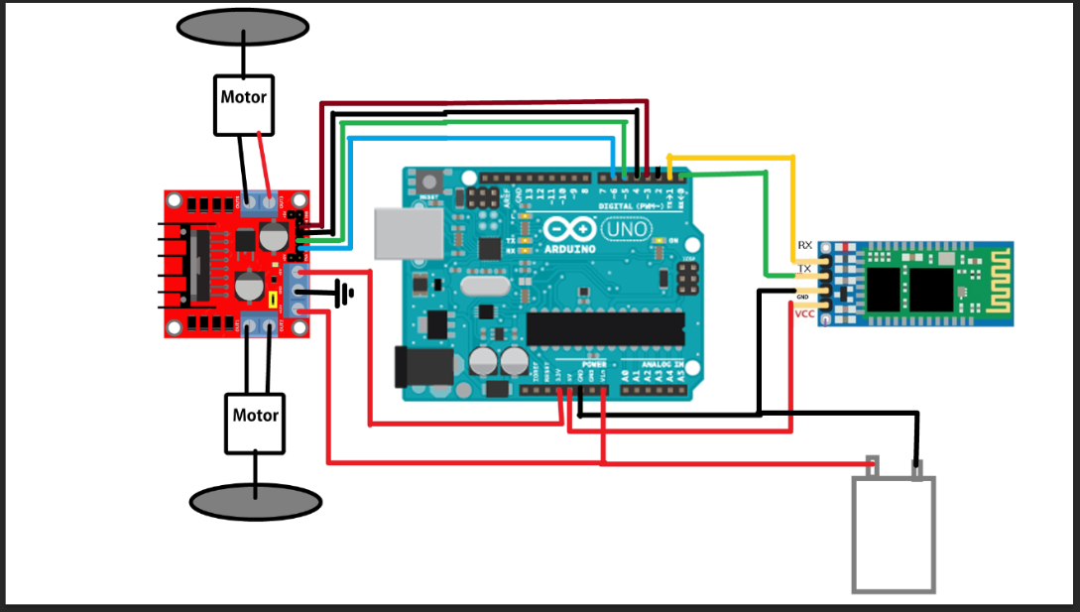

# Steps of Circuit Completion

* First of all I built the body of pet by using wood pieces.
* I attached all the four motors with wheels.
* Then I done the circuit by connecting Bluetooth module HC-05, Arduino UNO, L298N motor driver, 9 V cell and 12 V cell with the help of wires and jumper wires.
* Finally I designed the body which looks like a pet animal and I connected it with mobile phone for voice commands to run.

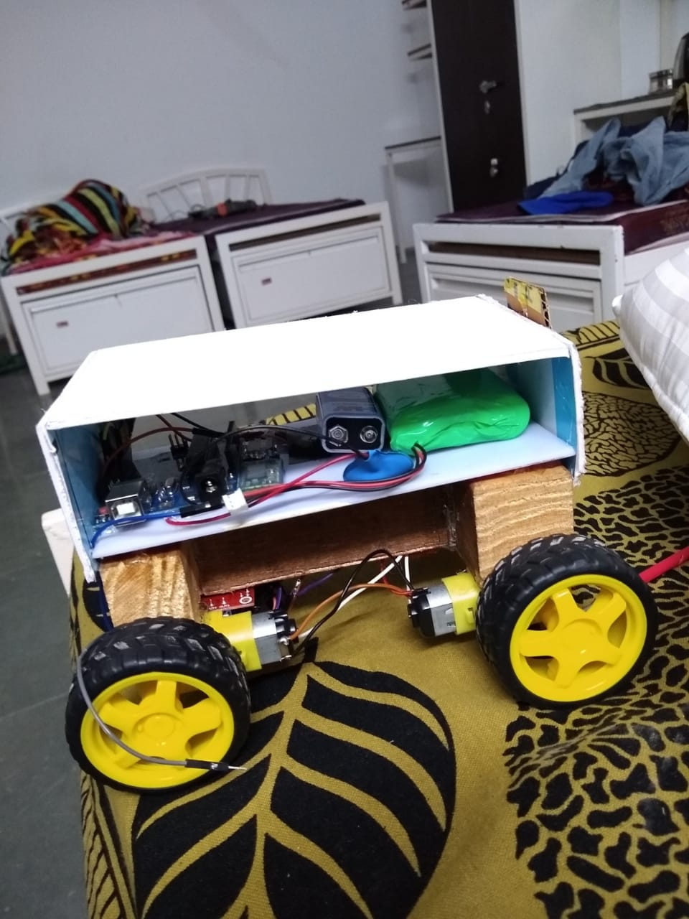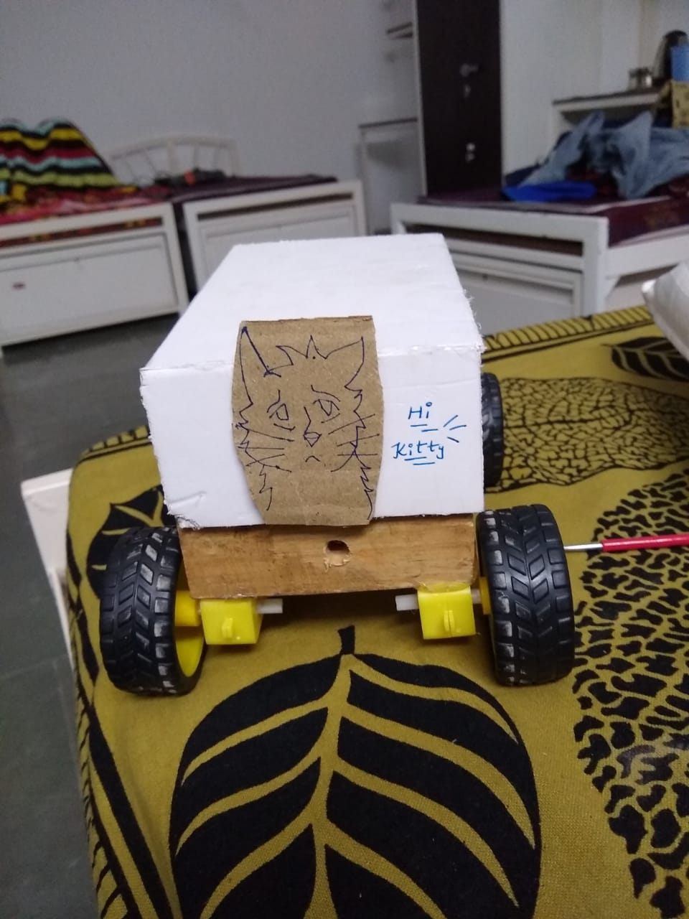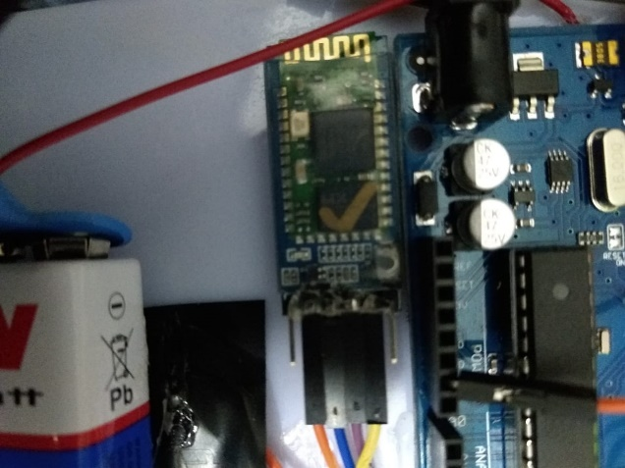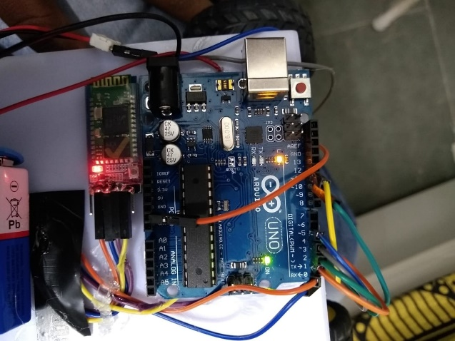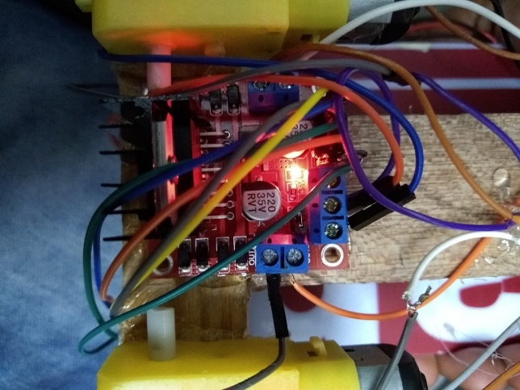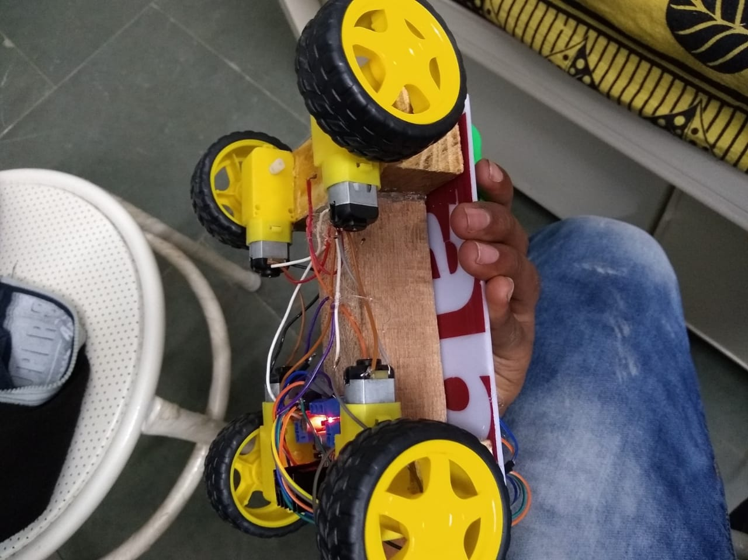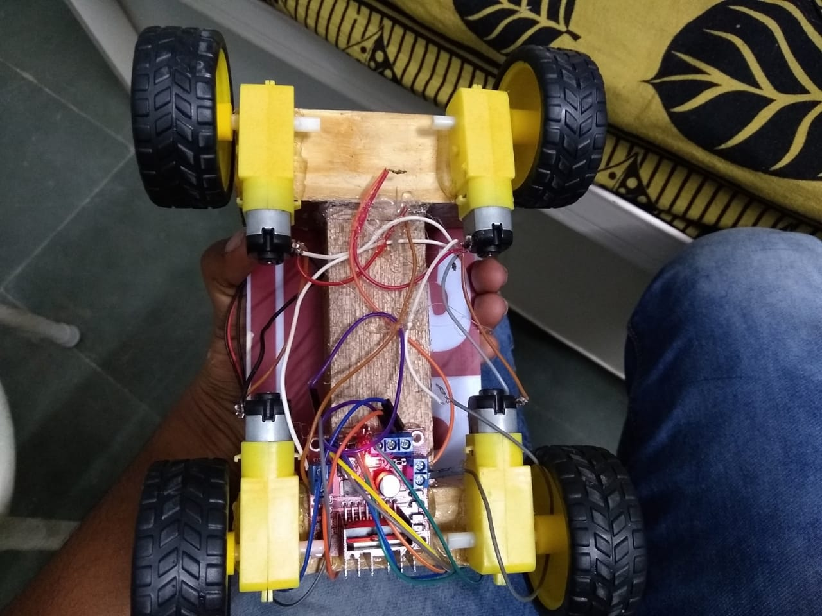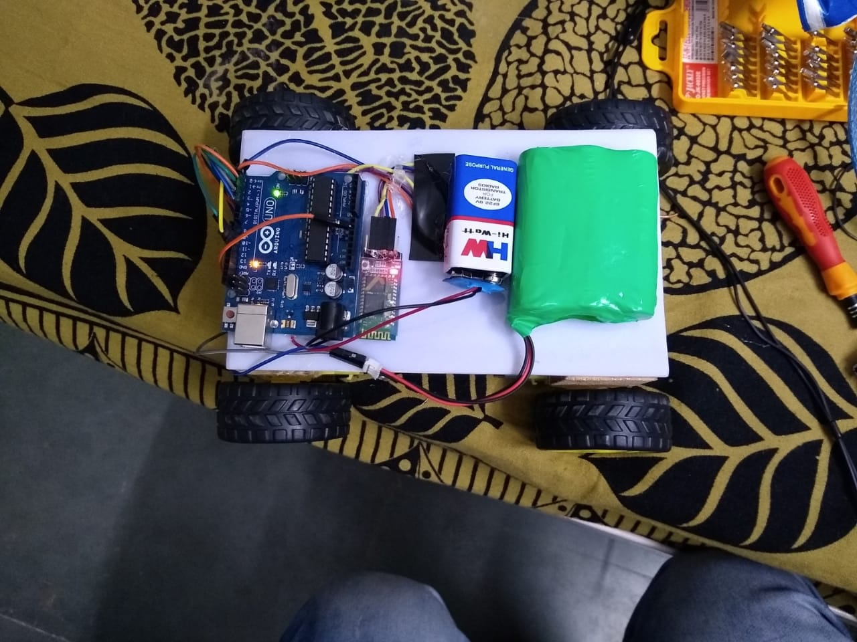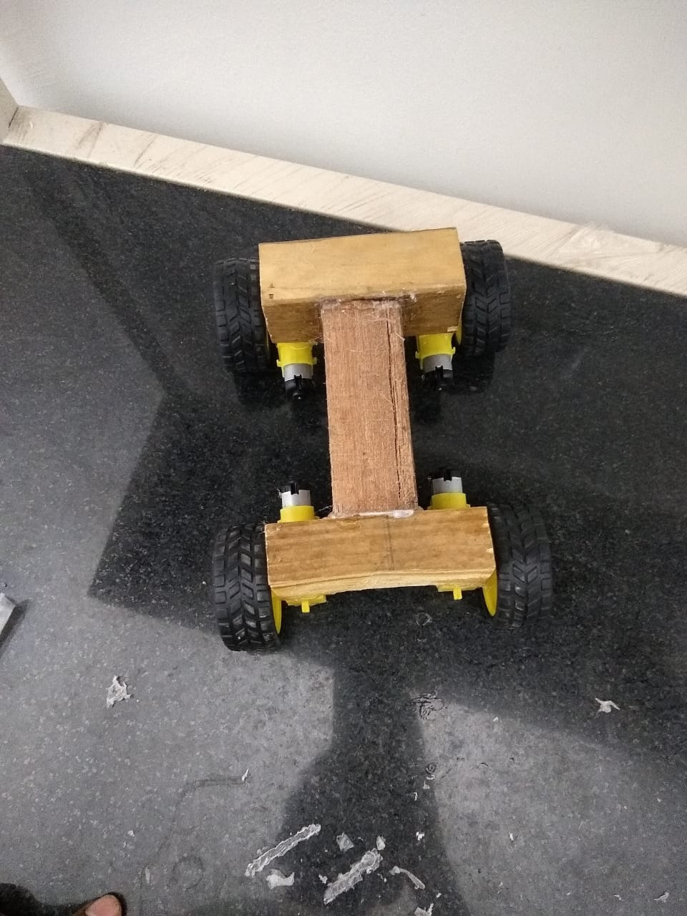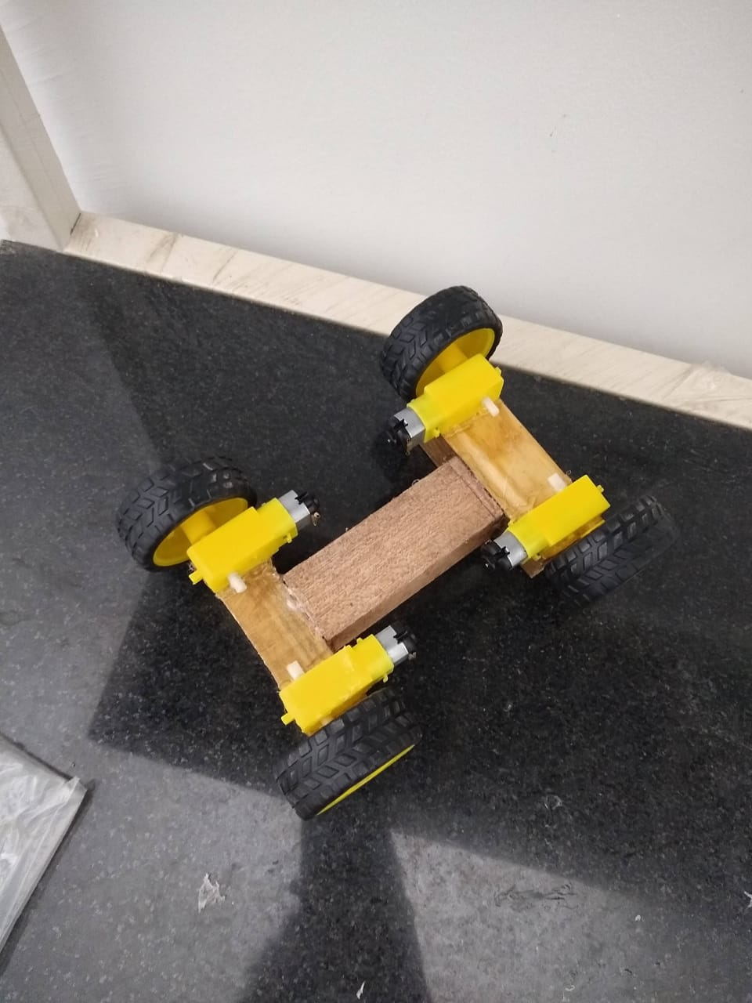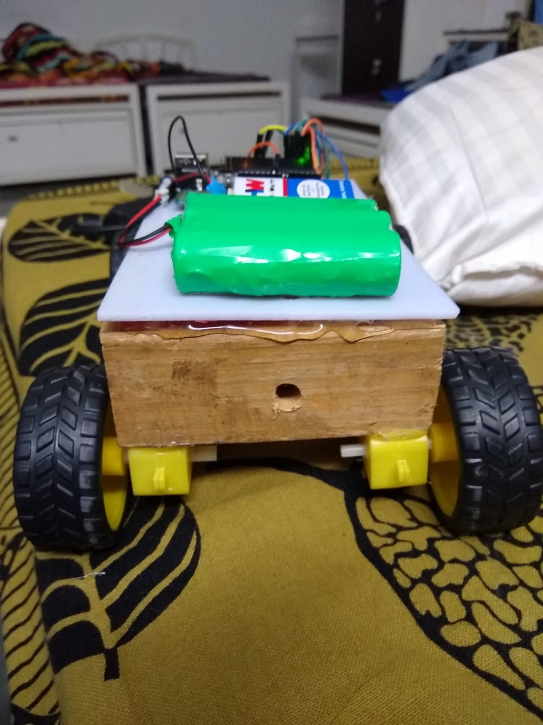

# Program Code

https://github.com/beeeproject-dsa/LAB/blob/master/ds_voice.ino